Work Break Down

- Name of Task: ToDo Application

- Estimated # of hours: 40

- Actual Time Spent:

- Notes: Using Wampserver64 3.0

- Issues:

Functional Requirements

- User can add tasks to list.

- User can remove tasks from list

- User can view all tasks

- User can assign a status to each task

- User can assign a due date to each task

- System displays the total number of tasks, as well as number of each status

- User can filter tasks by task status

Non-Functional Requirements

- Tasks will be entered into the application through a text form

- Tasks will be deleted by pressing a delete button associated with the specific task

- The system will display a list of all the user tasks

- Status will be associated with each task and can be changed through a drop down box

- Due dates will be assigned to each task through a text form associated to each task

- System will display a total number of tasks, as well as # of each status on a single line

- Clicking on a status count will open a new page displaying every task with that status

System Architecture Diagram

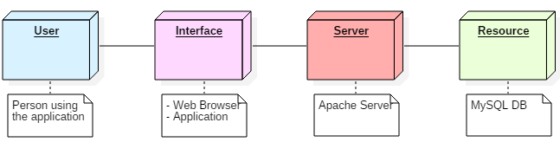

Data Flow Diagram

Use Cases

|  |  |
| --- | --- |
| Name |  |
| Description |  |
| Actors |  |
| Pre-conditions |  |
| Basic Flow |  |
| Alternate Flow |  |
| Post-conditions |  |
| Notes |  |

Sequence Diagrams

Database Design Diagram

Class Diagrams

Test Cases

|  |  |
| --- | --- |
| Name |  |
| Description |  |
| Steps |  |
| Outcome |  |
| Notes |  |